Djack’s Restaurant Project
Matt Ferry
MGMT404 Project Management
DeVry University

February 23, 2013

Contents
Executive Summary 3
Scope Statement 4
Work Breakdown Structure 7
Network Diagram 10
Risk Management Plan 11
Priority Matrix 11
Defined Impact Scale 12
Project Risks 13
Project Risk Justifications 14
Risk Ranking 18
Resource Management Plan 19
Assign Resources to Tasks 19
Identify Resources that are over-allocated 20
Gantt chart and Entry Table 21
Scope Technical Requirements Review and Final Time and Costs 25
Resource Costs: Resource Cost by Task 26
Resource Cost Cross Tab – Cost by Work 31
Level Project within available slack 41
Entry Table 42
Over-allocated resources 46
Assuming Over-allocated Resources 46
Communication Plan 47
Participation Report: 51

Executive Summary
Jean Luc Picard has approached us regarding the desire to open a new restaurant in the local area that serves family style food. He tried looking into the area demographics, restaurant design, and licensing, and construction himself, but discovered that it is more complicated than he had anticipated. As such, he has decided to hire Project Management 404 to help him overcome the project management issues that he is running into so that he can focus more on the details of the food and how he would like the restaurant to look. The restaurant should be 3000 – 4000 sq ft. with a fully functioning kitchen, In-House Soda brewing area and sufficient dining space. This project is expected to take no more than 6 months, and should finish well before that period has passed due to budgeting extra time into most areas to account for renovation delays that cannot be foreseen. Jean Luc Picard was able to specify our budget limit at $100,000. This means that the budget is a very tight budget however, it should be doable.

Scope Statement
Goal: To open a 3000 – 4000 sq. ft. Restaurant named Djack’s in a local shopping area that serves home-style and family food, within 6 months costing no more than $100,000.
Deliverables
- A 3000 – 4000 Sq. Ft. Restaurant building, ready to open.
- A fully equipped professional kitchen with proper refrigeration and walk in freezer.
- A fully equipped side area or section for In House Soda
- A Fully developed menu with items costing between $8 to $15.
Milestones:
- Signed Contract / Lease Agreement at a building location that meets the requirements for this restaurant. – March 1, 2013
- Initial Menu presented – March 8, 2013

- Approved Restaurant Design plans – March 22, 2013
- Kitchen, Customer Seating and POS System purchased and installed – April 19, 2013
- All Building and Initial Food and Health Inspections passed – April 26, 2013
- State required Licenses acquired – April 26, 2013
- Initial Menu Finalized – April 26,2013
- Local Restaurant Supply Store, and Food Service contracts acquired – May 10, 2013
- Staff Hired – May 10, 2013
- Staff Training Complete -- May 20, 2013
- Opening Day – May 22, 2013

- This project currently appears to have a lot of excess time allotted when considering the overall scope of 6 months. However, excess time was allotted during this phase for any issues that may arise and cause setbacks such as unable to find to an appropriate building location by the initial date, or building located but not yet complete or ordered kitchen equipment temporarily out of stock and unable to be delivered on time, etc.
Technical Requirements:
- Build and Health Code Requirements: The restaurant must pass all building and health code requirements.
- In House Soda: Must be sufficient for a minimum of 3 flavors
- Entertainment / Atmosphere: Must be wired for sound and have decent locations for 2 – 3 TV’s
- Order taking / POS: Must be capable of accepting orders from a POS system that supports wireless devices and wireless transmission to the kitchen.
- Food Storage: Must be able to store at least 1 week of frozen food (estimated), and 3 days of Fresh food (estimated).
- Kitchen: Must be capable of temporary storing, cleaning, containing, and cooking and delivering any food that is actively being prepared.
- Seating: Design plan for customer seating must have adequate seating for customers, as plenty of space for the servers to have easy access to the kitchen, In house soda area, and Customer tables without causing excess congestion during busy time periods.
- AC/Heat: Building must have adequate AC / Heat, so that customers are comfortable while eating.
Limits and Exclusions:
- Exterior: Will be limited to the general look of the building that is leased, to help reduce cost. Name Sign has been Ok’d for mounting to the exterior
- Interior: Construction and work hours are only permitted between 7 a.m. and 6.pm. Interior will also be designed and constructed according to the approved design plan.
- Sub-Contractor: The general contractor may sub contract work out other sources
- General Contractor: The general contractor will be held responsible for the work of sub-contractors

Work Breakdown Structure
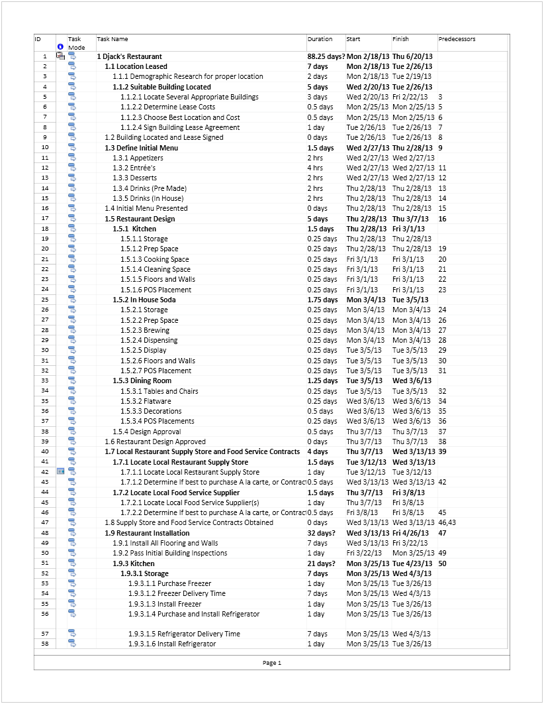

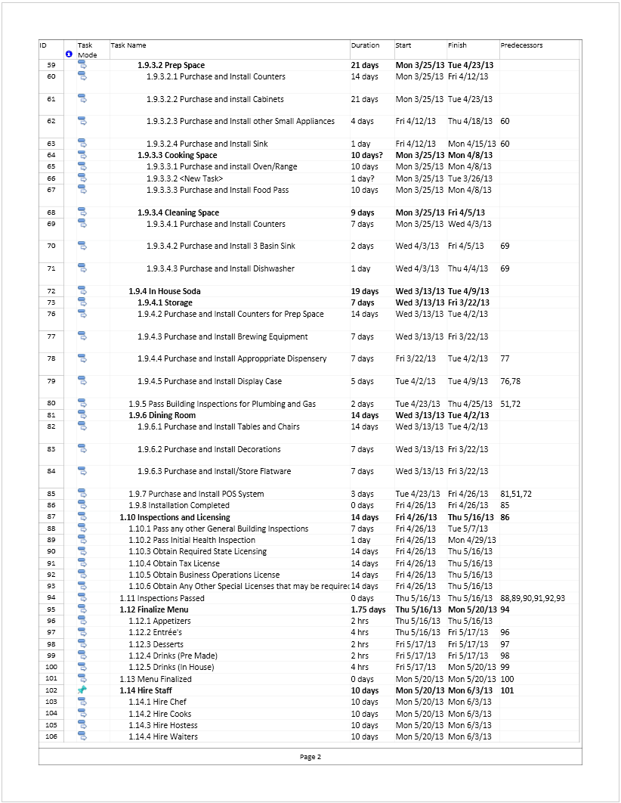

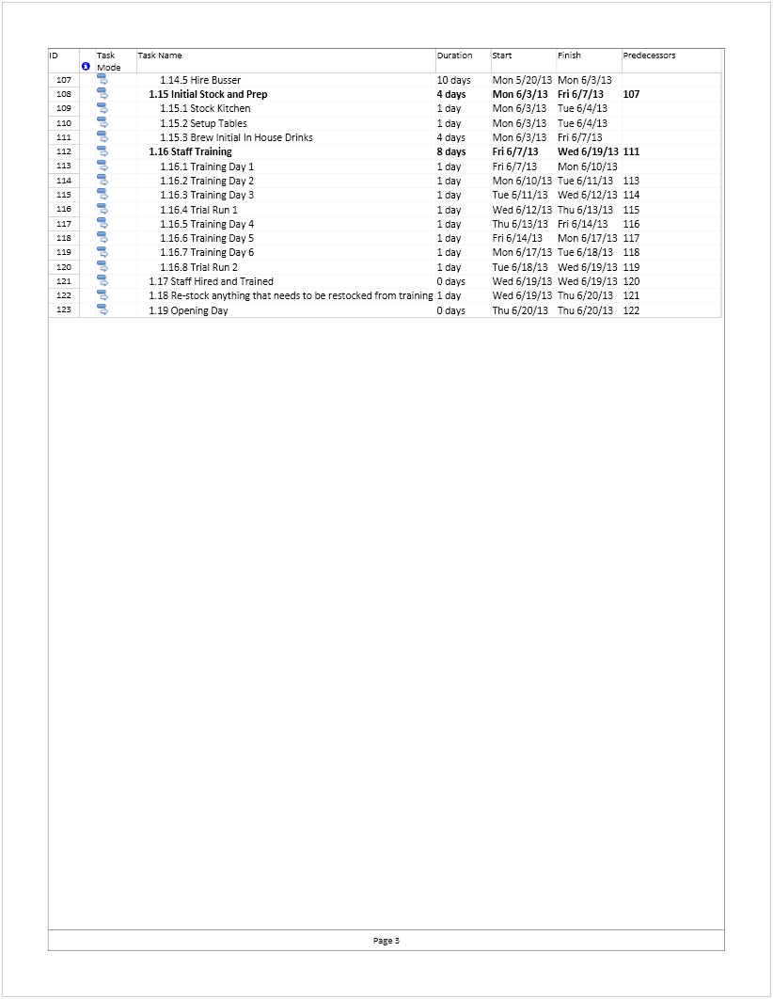

Network Diagram
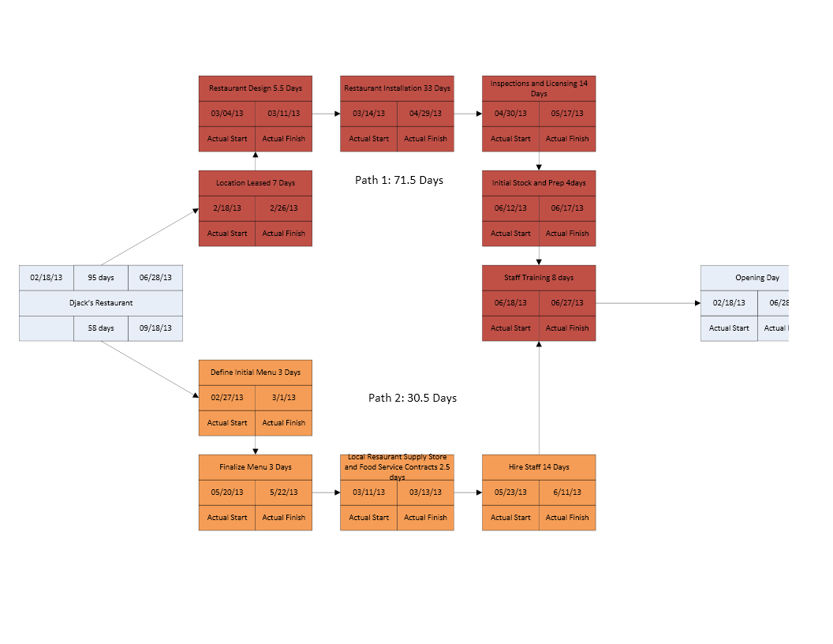

Risk Management Plan

Priority Matrix
 | Time | Performance | Cost
Constrain |  |  | X
Enhance |  | X
Accept | X

- Small budget means that cost needs to minimized or constrained where possible
- Performance should be enhanced through design and function
- Time will be accepted as there may be things outside of our control, and may need to be adjusted in order to maintain budget

Risk Management Plan (Cont.)

Defined Impact Scale

Project Objective | 1 - Very Low | 2 - Low | 3 - Moderate | 4 - High | 5 - Very High
Cost | Insignificant | 5% - 10% | 11% - 20% | 21% - 35% | > 35%
Time | Insignificant | 5% Time Increase | 10% Time Increase | 20% Time Incease | > 20% Increase
Scope | Barely Noticeable | Minor Changes | Major Changes | Reduction Unacceptable | Failed
Quality | Barely Noticeable | Only very minor aspects affected | Quality reduction - Approval Required | Reduction Unacceptable | Failed

Risk Management Plan (Cont.)

Project Risks

 | Risks
 | Risk Issue | Likelihood | Impact | Detection Difficulty | When
1 | Appropriate Building Located and Leased | 3 | 5 | 2 | Start of Project
2 | Indecision on Menu | 1 | 3 | 1 | Post Building Lease
3 | Design Issues | 3 | 5 | 1 | Post Building Lease
4 | Supplier Contract Issues | 2 | 4 | 4 | Post Installation
5 | Installation Issues (Unavoidable construction issues) | 4 | 4 | 5 | During Installation
6 | Inspections and Licensing Issues | 2 | 5 | 3 | During and Post Installation
7 | Finalize Menu | 1 | 4 - 5 | 3 | Post Installation / Pre Open
8 | Hire Staff | 2 | 4 | 2 | Post Installation / Pre Open
9 | Train Staff | 2 | 3 | 3 | Post Installation / Pre Open
10 | Stock and Prepare Issues | 2 | 4 | 3 | Post Installation/ Pre Open

Risk Management Plan (Cont.)

Project Risk Justifications
1. Appropriate Building Located and Leased - Has a moderate likelihood that there will be issues locating an appropriate building due to multiple constraints such as cost/month, location, and zoning laws that all need to be verified before any lease can be signed. The impact is very high because without a building there can be no restaurant. Detection difficulty on this should be easy, because these are all things that have to be checked before anything can be signed.
2. Indecision on Menu - Likelihood of this occurring is very low because in general the restaurant owner should already know what type of restaurant they want to open. Impact is at moderate because what the restaurant will server will determine what type of storage/preparation/cooking areas will be required, which could potentially affect the design of the restaurant if there is specialty equipment involved. Detection difficulty for this is low because it should be easy to determine if the restaurant owner is undecided.
3. Design Issues - Likelihood is at moderate levels because the initial dimensions of the restaurant are currently unknown and those dimensions may generate design issues that have to be worked around, and approved. This could potentially increase the time of the project if design revisions have to be exchanged and redone several times before approval is given. Detection difficulty on this is minimal because we know in advance that the building for the restaurant will be a pre-built building instead of a new custom building.

Risk Management Plan (Cont.)
4. Supplier Contract issues - Likelihood is set to low because this should be nothing more than locating and formalizing contract agreements to have the necessary supplies supplied once the restaurant is completed. Impact is still high because if there is an unavoidable contract or agreement issue it could increase the time required to open the restaurant. Difficulty detection is high because you will be working with a third party company that is outside of your direct control.
5. Installation issues - This is marked at high because in every form of construction or renovation there will be unknown and unavoidable construction expenses that will arise. These expenses could have a high impact on the cost and time of the project (very high means something went wrong in planning and design). Detection Difficulty is at very high because some issues may not even present themselves until you are midway through the installation process.
6. Inspections and Licensing issues - As this restaurant is being properly planned out the likelihood of this occurring is low, although it's impact is very high because if inspections and licenses are not acquired the restaurant will not be allowed to open. Detection difficulty is listed as moderate only because even though the designs and installation say everything is to code and inspector could still say otherwise.

Risk Management Plan (Cont.)
7. Finalize the Menu - Likelihood of issues occurring here are very low because there should only be a few minor changes made to the menu that do not require changes to any of the restaurant designs because the initial menu will be used to determine the restaurant design. Potential Impact is listed as high to very high because major to extreme changes in the menu could potentially cause the restaurant owner to ask for something that was not in the original design plan. Detection difficulty is at Moderate because any change at this point to the menu needs to be approved because it will be the menu that the restaurant opens with.
8. Hire Staff - Likelihood of issues occurring here is low. Even if there are some issues hiring staff, that process should not cause the project time to increase by more than 5% unless something drastically goes wrong. It has a High Impact level because without staff you cannot operate a restaurant very well, and it's detection difficulty is at low because there really shouldn't be an issue with hiring people unless you are looking for employee skills that are outside the scope of the restaurant (i.e. 5 star gourmet chef, for a family style restaurant)
9. Train Staff - Likelihood is low because by the time the staff have been hired the building should be complete and the training process should proceed as planned. Impact is listed at Moderate because if the staff is not successfully trained the restaurant opening will need to be delayed until they are properly trained. This is also why 2 trial runs have been scheduled.

Risk Management Plan (Cont.)
10. Stock and Prepare Issues – likelihood is low , with a fully developed menu that has been finalized the restaurant should know what it needs for opening day and should be able to be properly stocked in time for the restaurant opening. Impact of a stock issue is marked as moderately because it will affect the overall launch of the restaurant (you do not want to be running out of food on the first day). Detection difficulty is set at Moderate because all you can do is estimate how much food you think you will need for the first few days and stock based on those numbers, If you have a rush on particular items it may be hard to keep everything stocked until the restaurant develops a better business rhythm.

Risk Management Plan (Cont.)

Risk Ranking
Risk Ranking | Likelihood | Impact | Detection Difficulty | Risk Rating
Installation Issues (Unavoidable construction issues) | 4 | 4 | 5 | 80
Supplier Contract Issues | 2 | 4 | 4 | 32
Appropriate Building Located and Leased | 3 | 5 | 2 | 30
Inspections and Licensing Issues | 2 | 5 | 3 | 30
Hire Staff | 3 | 4 | 2 | 24
Stock and Prepare Issues | 2 | 4 | 3 | 24
Train Staff | 2 | 3 | 3 | 18
Design Issues | 3 | 5 | 1 | 15
Finalize Menu | 1 | 4 | 1 | 4
Indecision on Menu | 1 | 3 | 1 | 3

Resource Management Plan

Assign Resources to Tasks
We allocated and assigned all “work” related first, and then went back and assigned material resources. Below is our resource sheet.
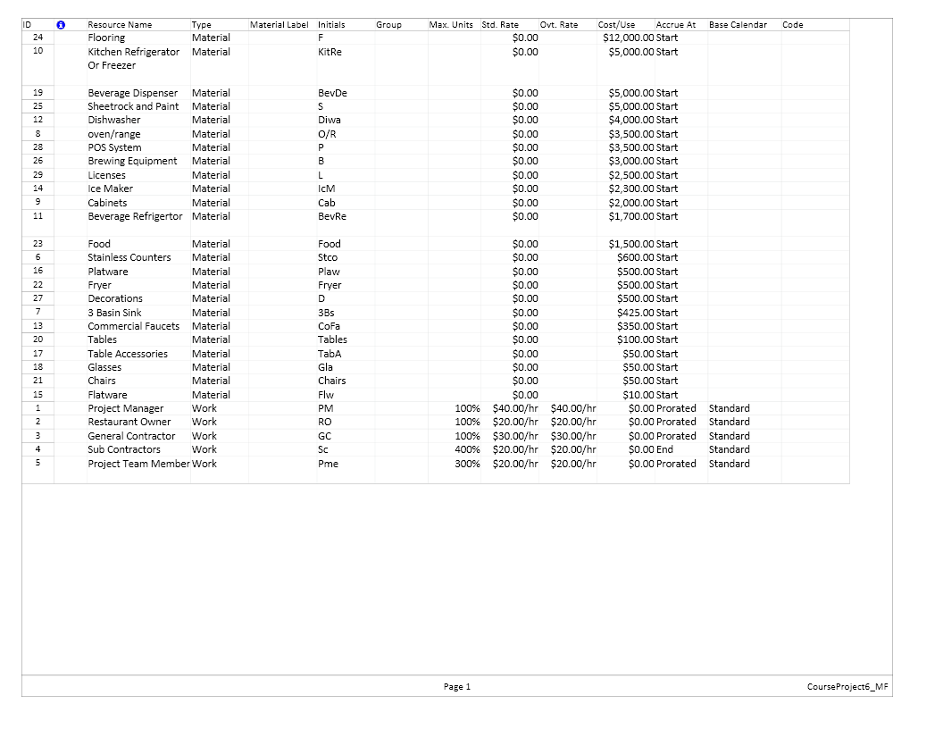

Resource Management Plan (Cont.)

Identify Resources that are over-allocated
We actually dealt with over-allocated resources as the appeared. The resources that we had the most issues with being over-allocated were the Restaurant Owner, General Contractor and Sub Contractors.

Resource Management Plan (Cont.)

Gantt chart and Entry Table

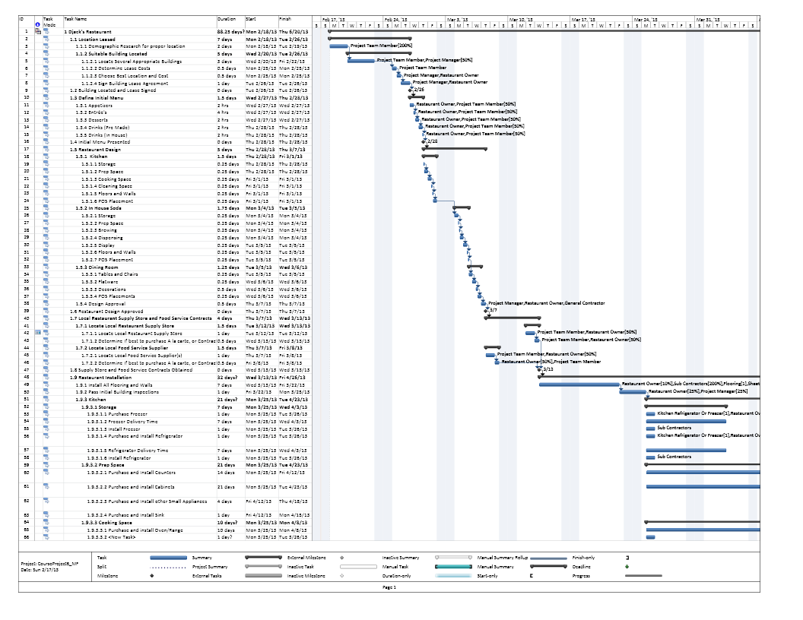

Resource Management Plan (Cont.)
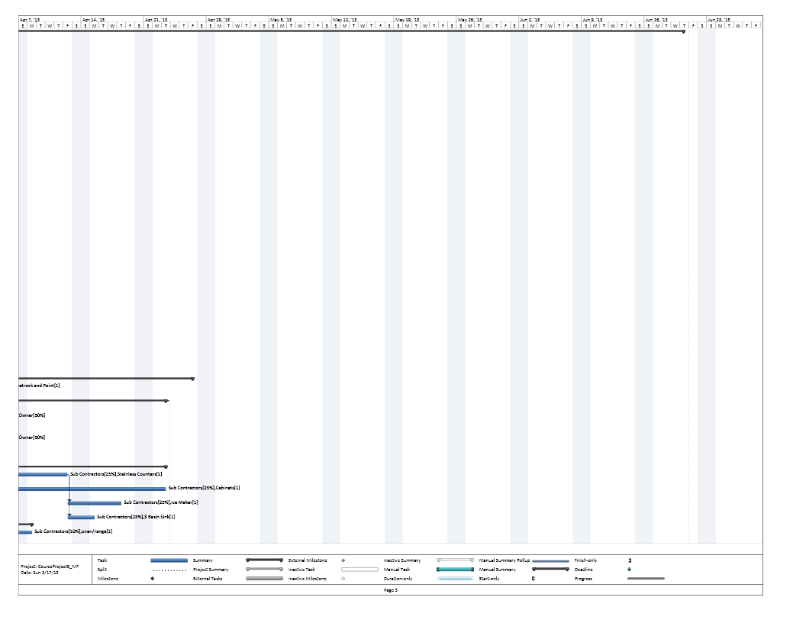

Resource Management Plan (Cont.)
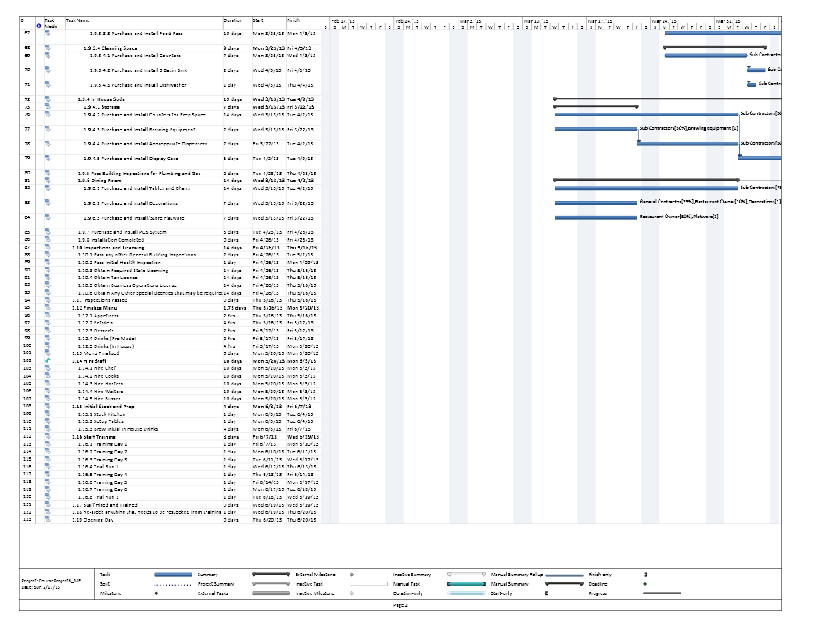

Resource Management Plan (Cont.)
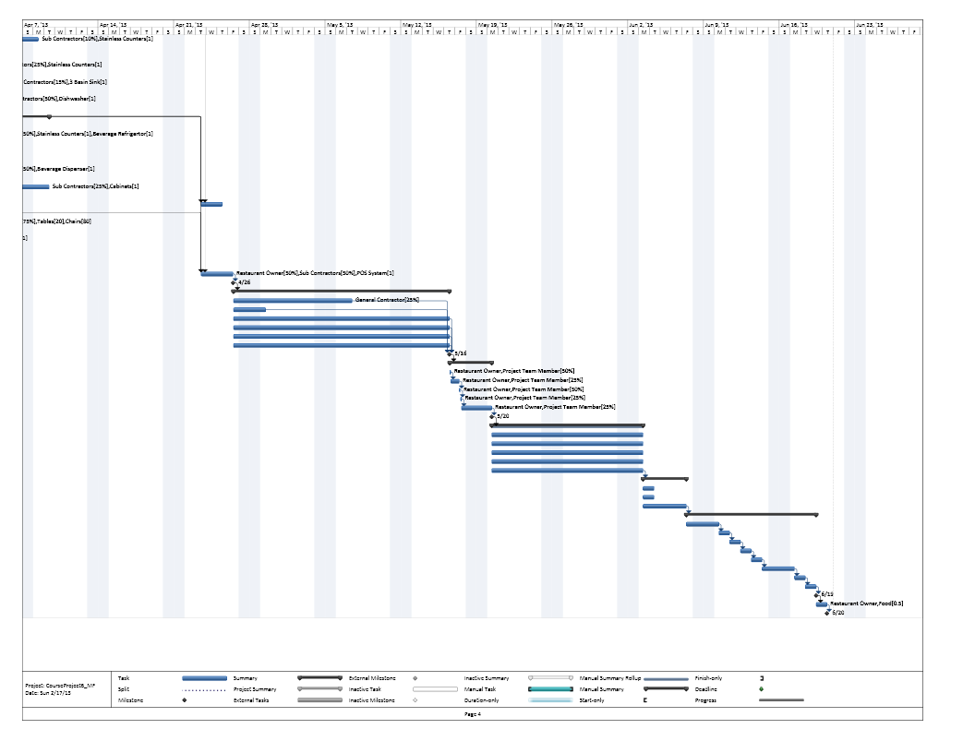

Resource Management Plan (Cont.)

Scope Technical Requirements Review and Final Time and Costs
Technical Requirements:
- Build and Health Code Requirements: The restaurant must pass all building and health code requirements. - Inspections and Licensing have been included within the project to ensure this quality level.
- In House Soda: Must be sufficient for a minimum of three flavors - Brewing Area to be designed will accommodate this requirement.
- Entertainment / Atmosphere: Must be wired for sound and have decent locations for 2 – 3 TV’s - Given the size of the location this will be taken into account in the restaurant design.
- Order taking / POS: Must be capable of accepting orders from a POS system that supports wireless devices and wireless transmission to the kitchen. - POS purchase system is up to the restaurant owner; however, the restaurant will be able to support any POS system that is purchased.
- Food Storage: Must be able to store at least 1 week of frozen food (estimated), and 3 days of Fresh food (estimated). - Restaurant Freezer and Refrigerator needs should be met in the design with the installation of the freezer and refrigerator.
- Kitchen: Must be capable of temporary storing, cleaning, containing, and cooking and delivering any food that is actively being prepared. - Will be taken into consideration during the restaurant design phase and include everything required.
- Seating: Design plan for customer seating must have adequate seating for customers, as plenty of space for the servers to have easy access to the kitchen, In house soda area, and Customer tables without causing excess congestion during busy periods.

- AC/Heat: Building must have adequate AC / Heat, so that customers are comfortable while eating. - This requirement should be included with the building that is purchased and taken into consideration when choosing the location.
The Project is currently within budget at $98,302 (budgeted $100,000), and 88.25 days (budgeted 6 months),

Resource Management Plan (Cont.)

Resource Costs: Resource Cost by Task
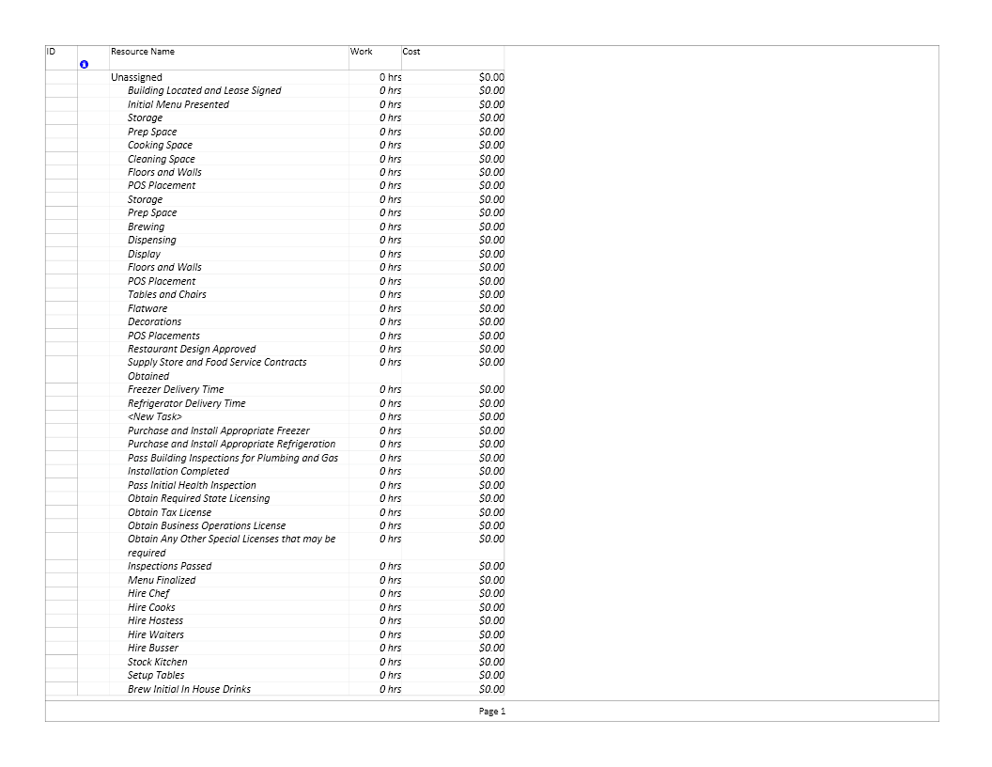
Resource Management Plan (Cont.)
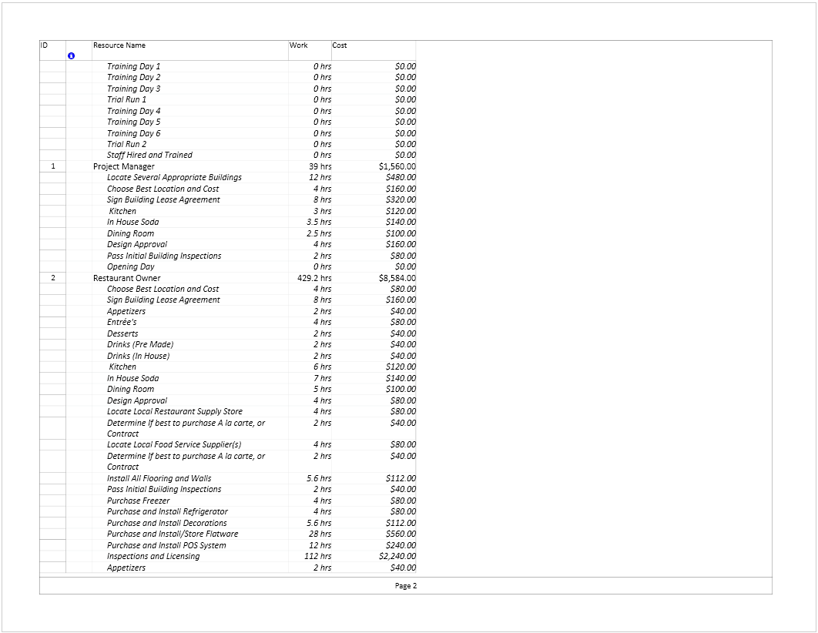
Resource Management Plan (Cont.)

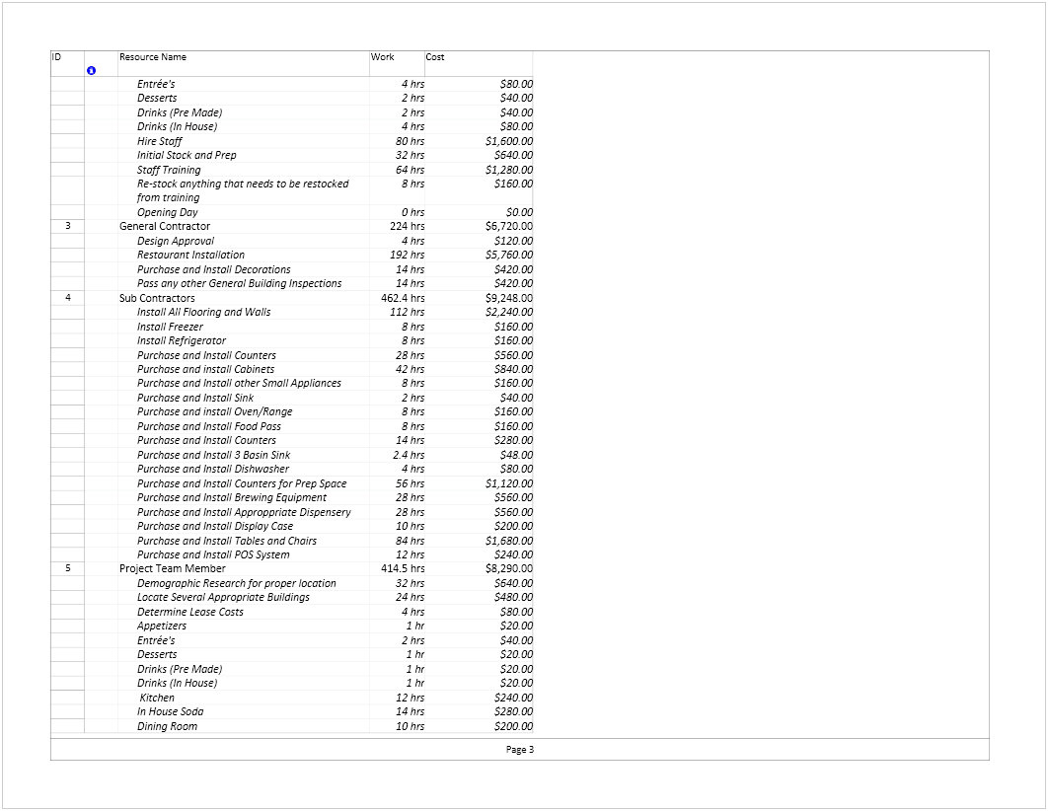
Resource Management Plan (Cont.)

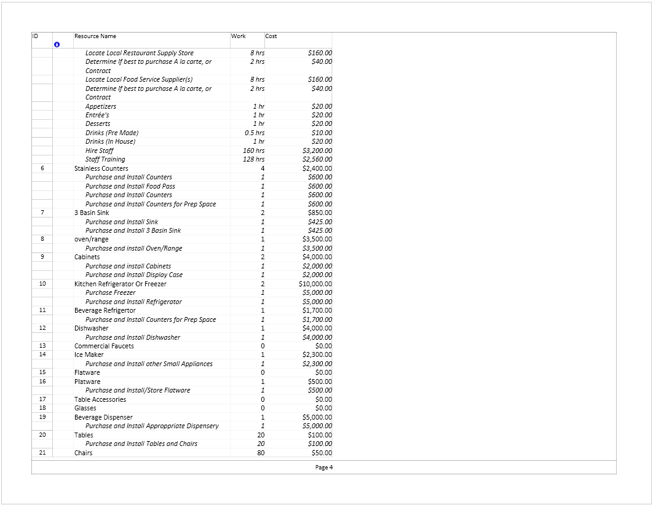
Resource Management Plan (Cont.)

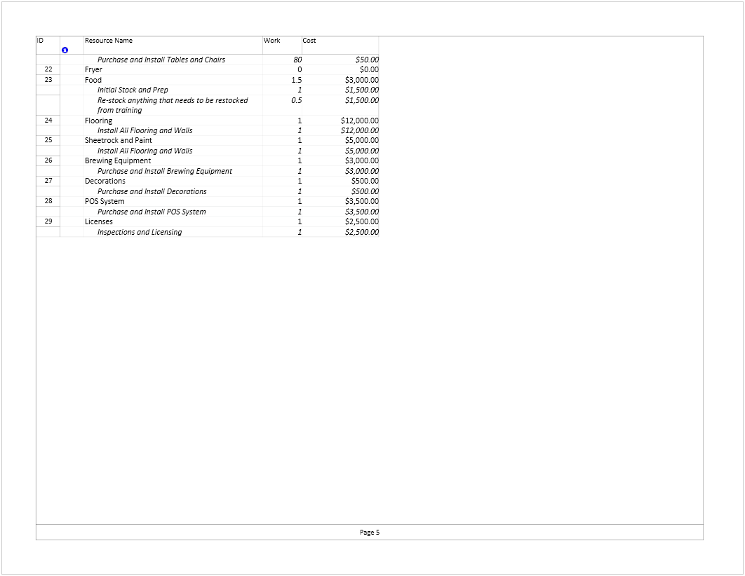

Resource Management Plan (Cont.)

Resource Cost Cross Tab – Cost by Work

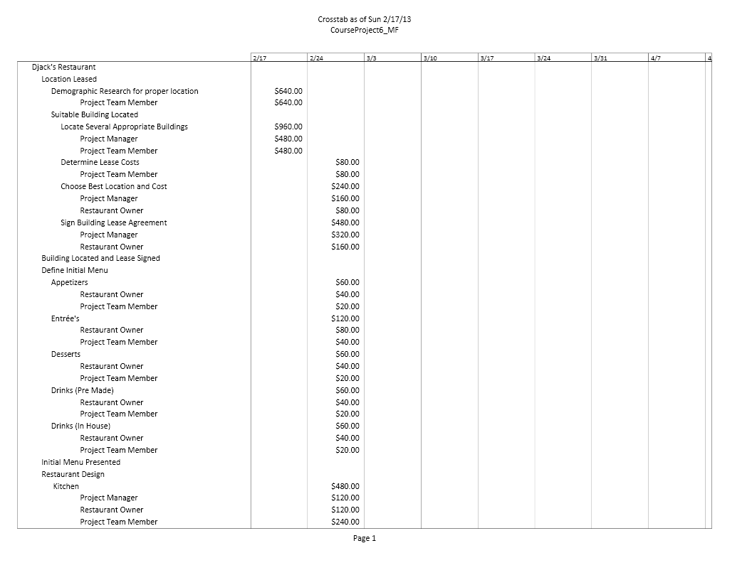
Resource Management Plan (Cont.)
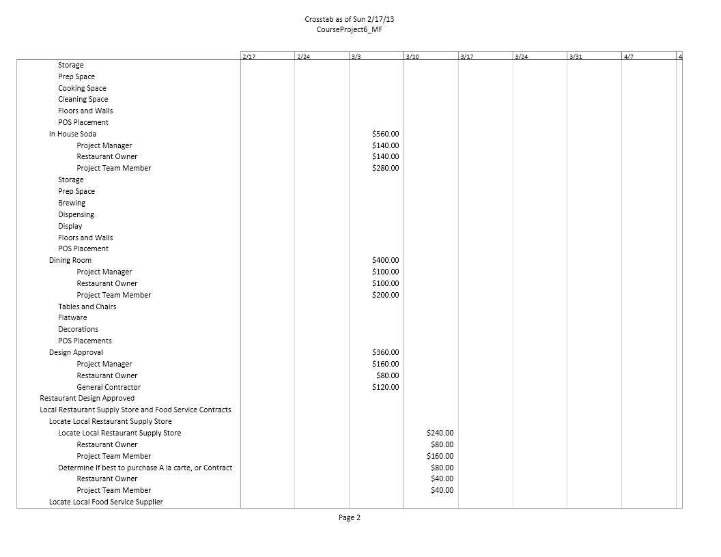

Resource Management Plan (Cont.)
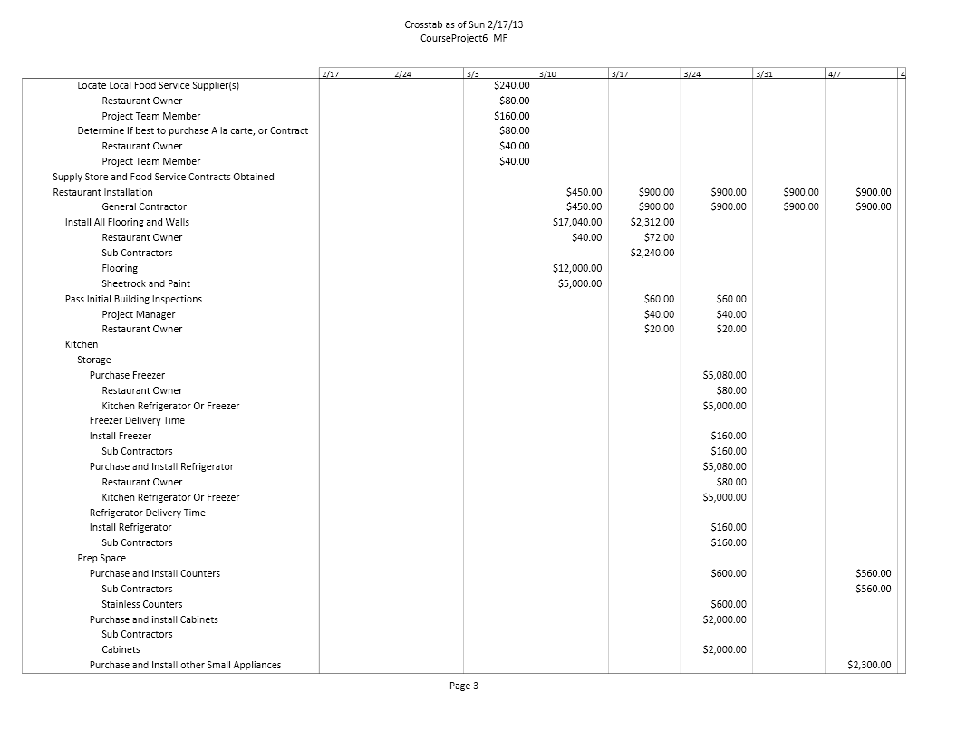

Resource Management Plan (Cont.)
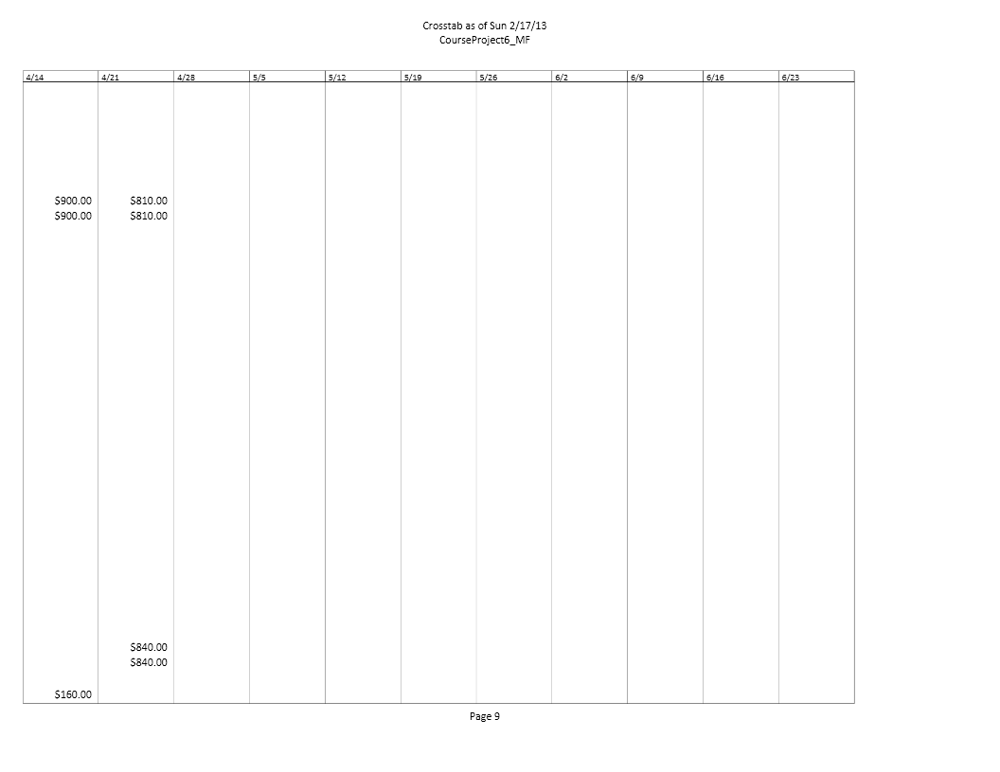

Resource Management Plan (Cont.)
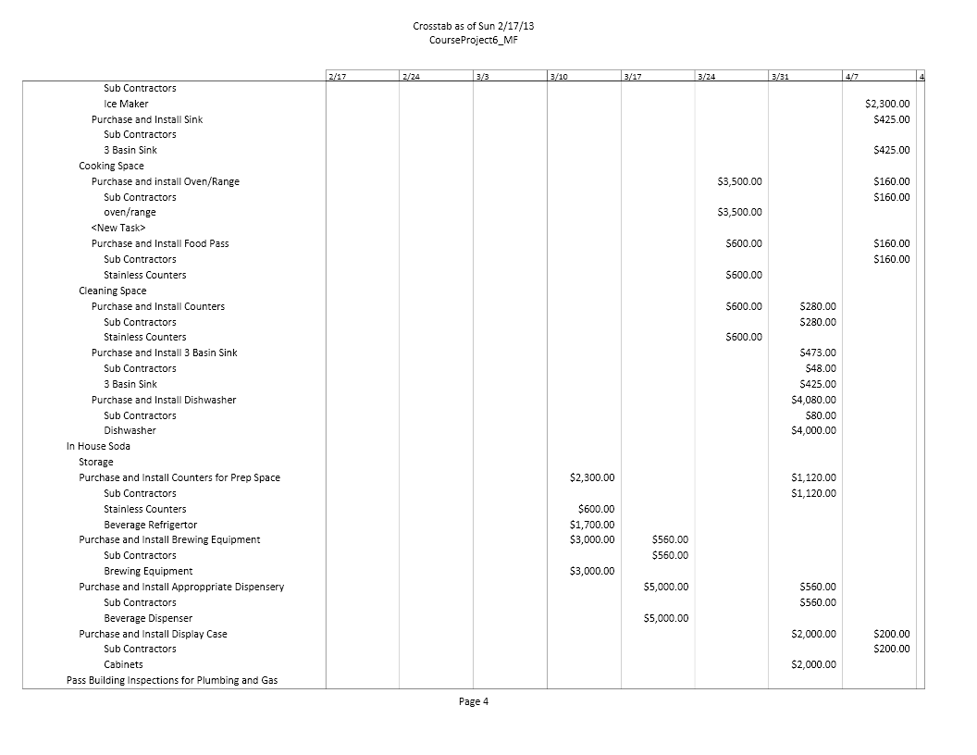
Resource Management Plan (Cont.)
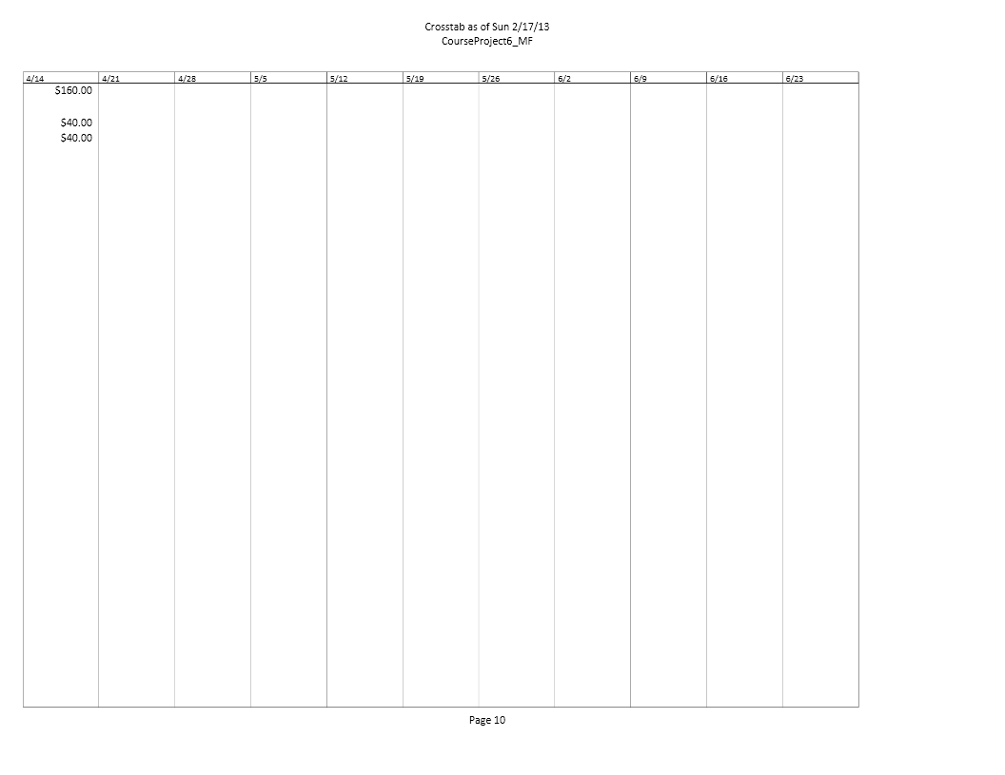

Resource Management Plan (Cont.)
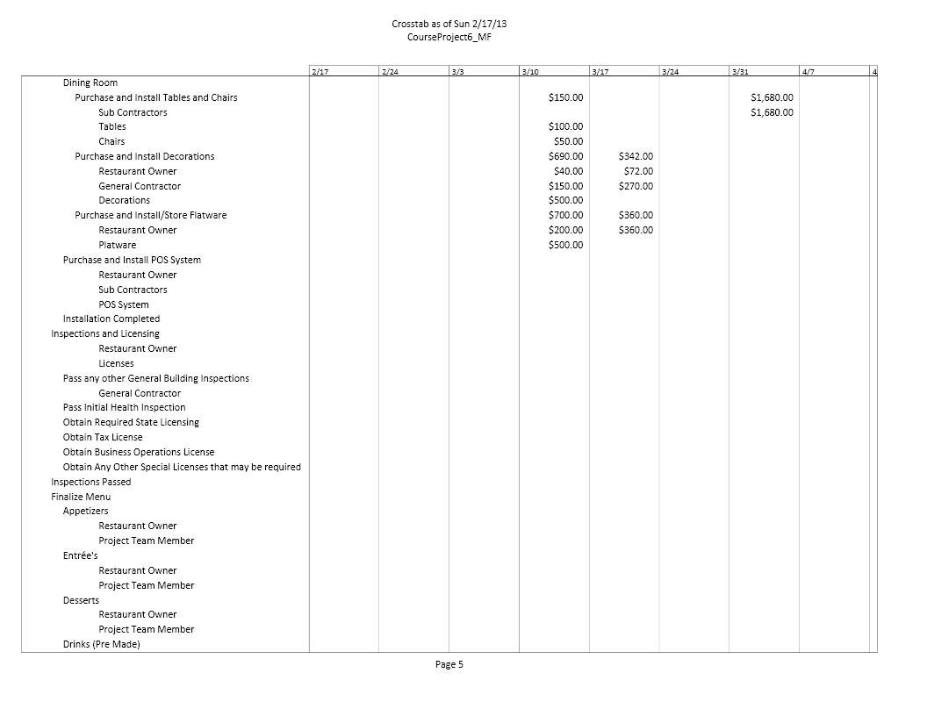
Resource Management Plan (Cont.)
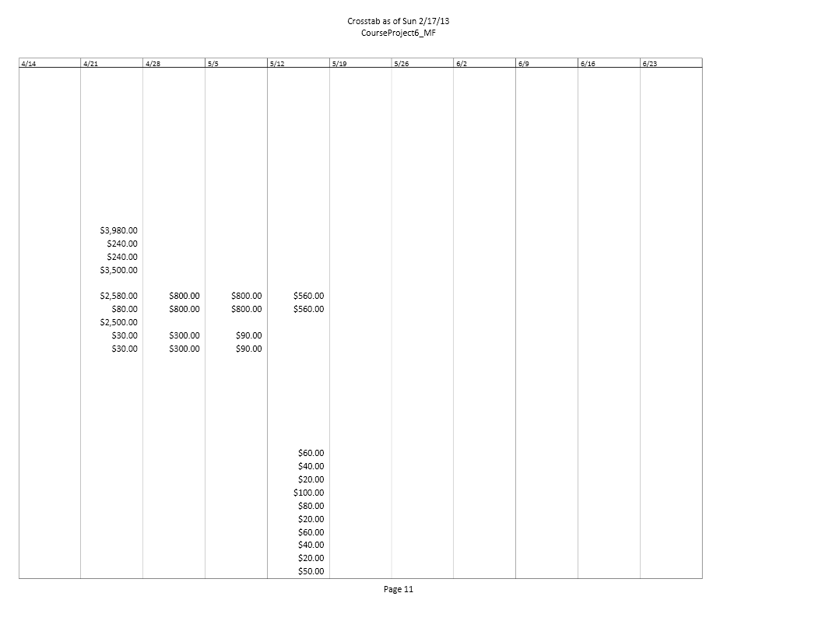

Resource Management Plan (Cont.)
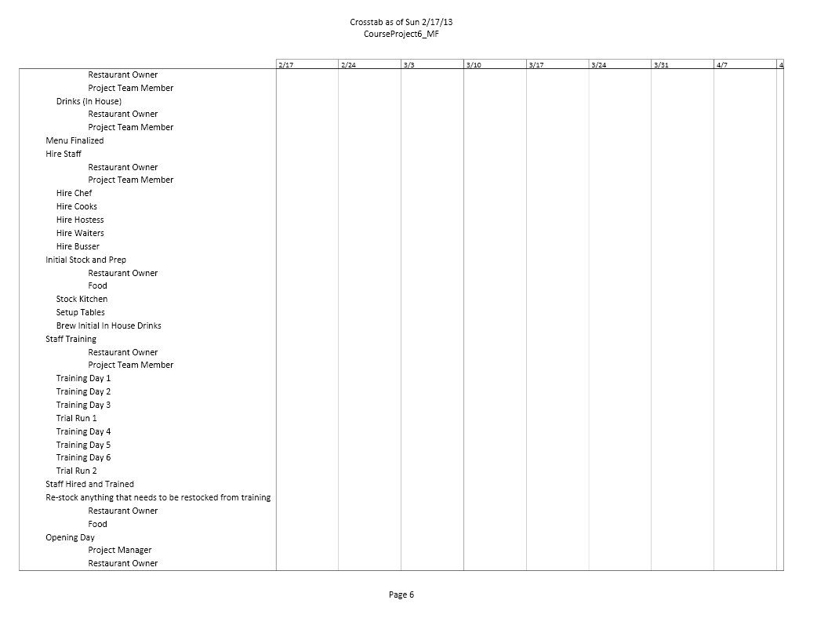
Resource Management Plan (Cont.)
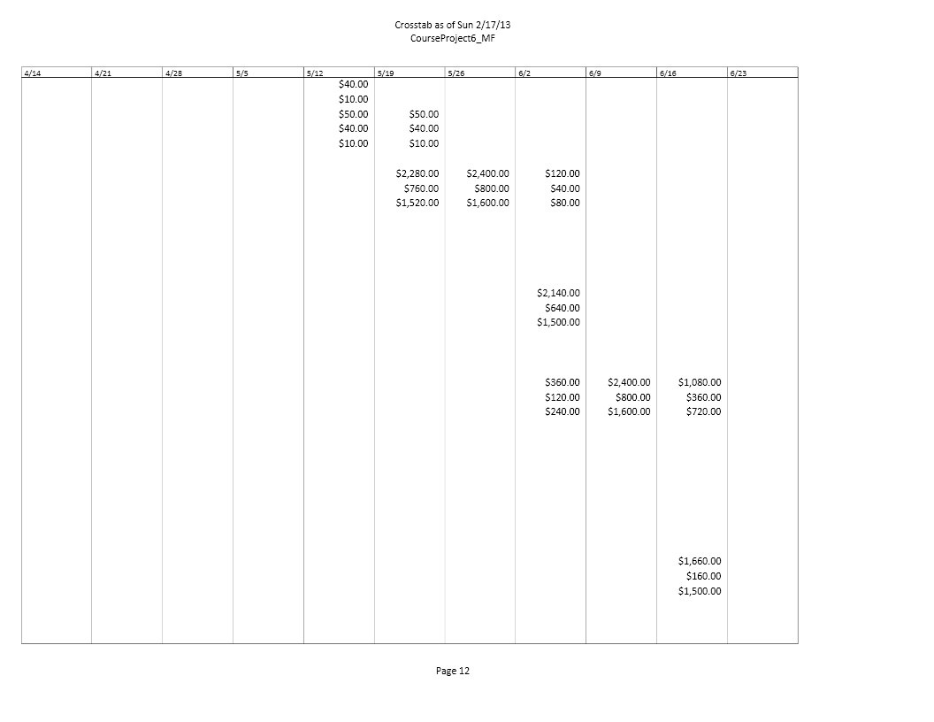
Resource Management Plan (Cont.)

Level Project within available slack
As we did not have any over allocated resources by the time we reached this phase, we will discuss how we dealt with over allocations.
For the Restaurant Owner and General Contractor, we dealt with over-allocations by reducing the amount of time that they were allocated to individual resources; we also decided to allocate them globally in several instances, such as instances where they had participate in every sub process. The “Restaurant Installation” for the General Contractor, is a good example of this, as the General Contractor he needs to checking and verifying the work that is done during every step of the installation process.
For the Sub-Contractors over-allocation issues, as this resource is sub-contractors, and the number of needed sub-contractors is not easily known these over-allocations were resolved by increasing the available amount of sub-contractors so that the General Contractor should have the resources needed in order to install everything.

Resource Management Plan (Cont.)

Entry Table
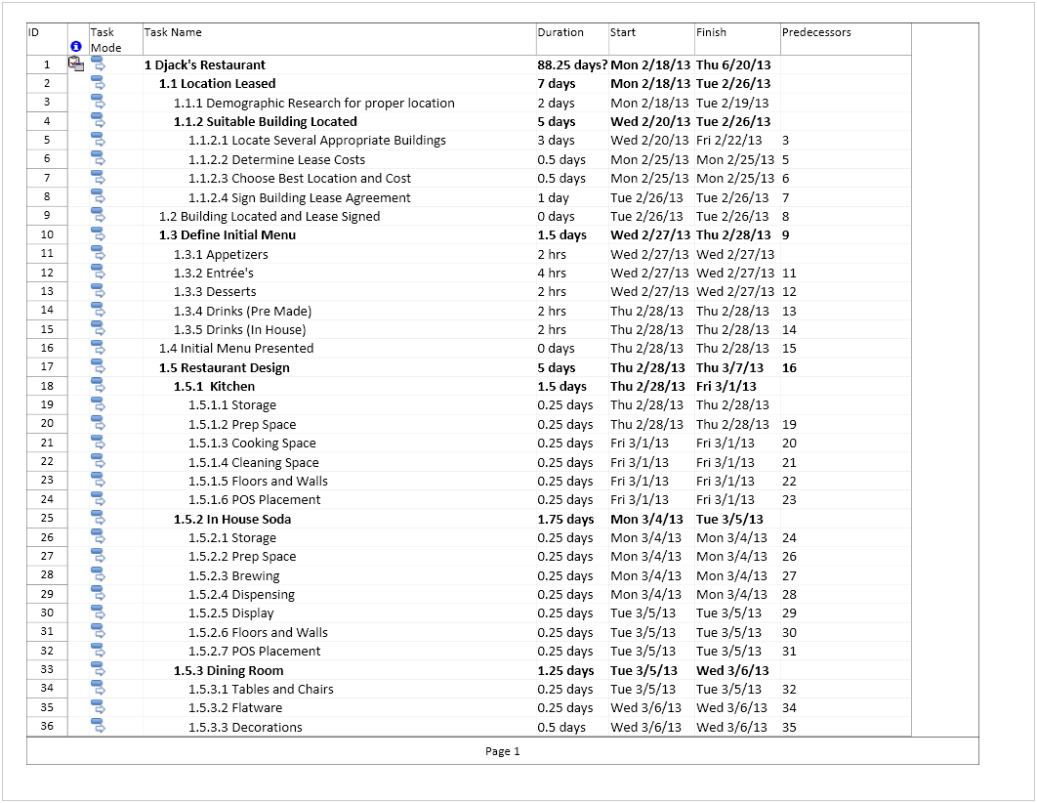

Resource Management Plan (Cont.)

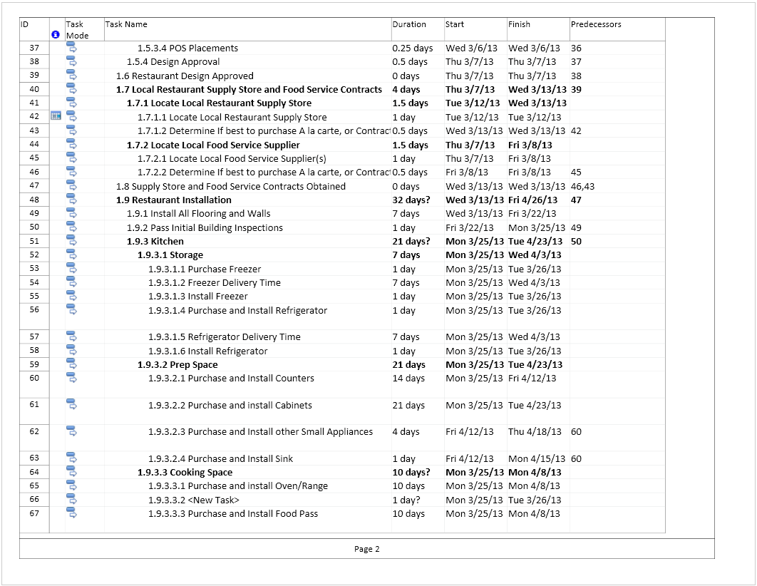

Resource Management Plan (Cont.)

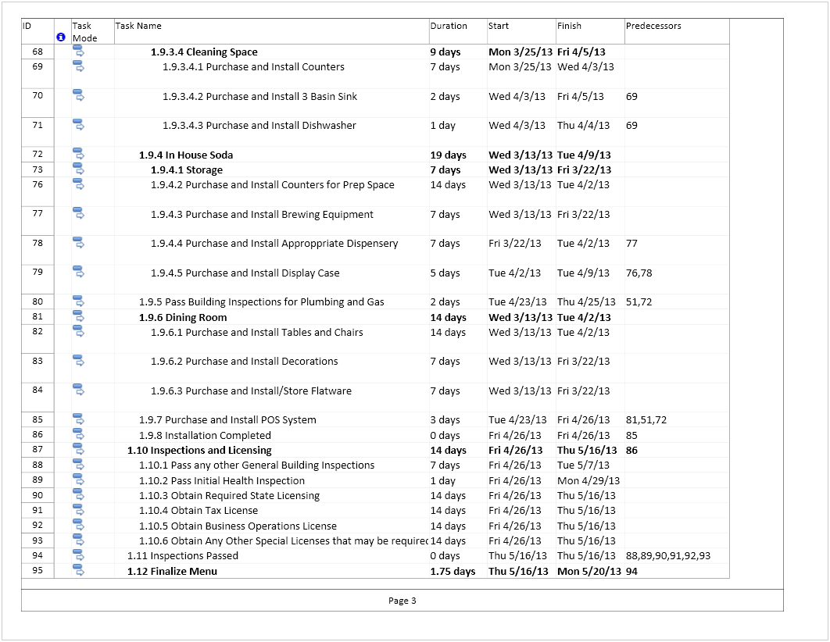

Resource Management Plan (Cont.)

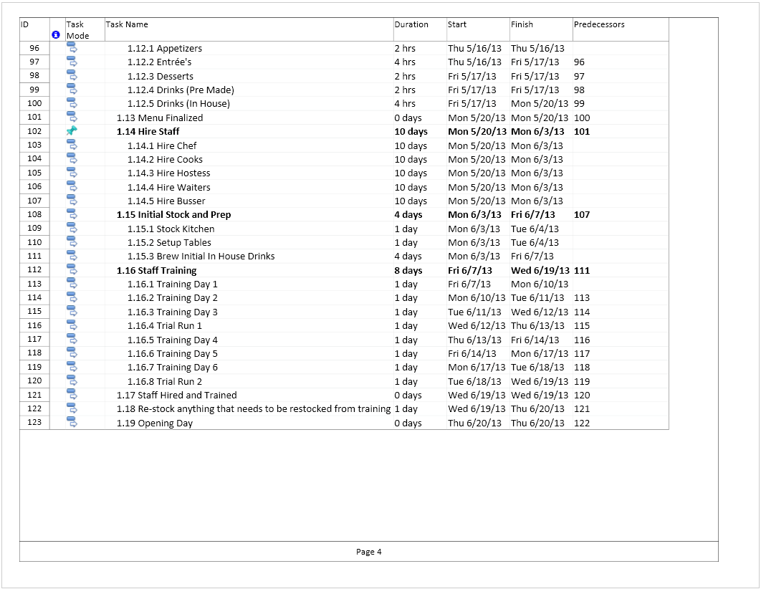

Resource Management Plan (Cont.)

Over-allocated resources
There are currently no Over-allocated Resources

Assuming Over-allocated Resources
As there were no remaining over-allocated resources assuming that there was still an over allocation, the best thing to do is to look for everywhere where extra time is available or if over budget where extra costs can be cut. For example, this project was initially over budget by nearly $15,000, which technically is a huge over-allocation of resources.
By reducing several minor time periods, such as the amount of time required to prepare and finalize the menu’s we were able to trim the budget down to just $110,000. However, this is obviously still over budget. The remainder of the over-budget issue was resolved by doing further research on several resource cost areas, and adjusting prices accordingly. By being able to reduce costs on things like tables and counters by using prices from http://www.webstaurantstore.com/ , the budget was brought in line.

Communication Plan

General Information:
Prepared by: Matt Ferry
Date: February 23, 2013
Authorized by: Matt Ferry
Stakeholder List and Contact Information:
Name | Position | Email | Phone
Matt Ferry | Project Manager | mferry@projectmgmt.com | 555-555-1234
Jane Doe | Project Team Member | jadoe@projectmgmt.com | 555-555-1233
John Doe | Project Team Member | jodoe@projectmgmt.com | 555-555-1232
William Riker | Project Team Member | wtriker@projectmgmt.com | 555-555-1231
Jean Luc Picard | Restaurant Owner | picard@djackrestaurant.com | 555-444-1234
Geordi La Forge | General Contractor | laforge@generalcontracting.com | 555-333-7896

Communication Plan (Cont.)
Major Deliverables and Escalation Information:
Name | Responsible | Issue Time | Escalation Path
Lease Signed | Jean Luc Picard | 30 Days | Jean Luc Picard / Matt Ferry
Initial Menu | Jean Luc Picard / John Doe | 1 Day | Matt Ferry / Jean Luc Picard
Restaurant Design | Jean Luc Picard / William Riker | 7 Days | Geordi La Forge / Matt Ferry
Supplier Contracts | Jean Luc Picard / Jane Doe | 7 Days | Jean Luc Picard / Matt Ferry
Inspections and Licensing | Jean Luc Picard / Geordi La Forge | 7 Days | Jean Luc Picard / Matt Ferry / Geordi La Forge
Restaurant Installation | Geodi La Forge | 36 Days | Jean Luc Picard /Matt Ferry
Finalize Menu | Jean Luc Picard/ John Doe | 2 Days | Jean Luc Picard/ Matt Ferry
Hire Staff | Jean Luc Picard/ Jane Doe | 14 Days | Jean Luc Picard/ Matt Ferry
Train Staff | Jean Luc Picard/ Jane Doe | 10 Days | Jean Luc Picard / Matt Ferry
Stock And Prep | Jean Luc Picard / Jane Doe | 4 Days | Jean Luc Picard / Matt Ferry

Communication Plan Details:
The Project Manager, Restaurant Owner, and General Contractor and Project Team members (when applicable) will be updated on the status of the project during a weekly meeting or conference call.
All issues will be tracked via documentation of the issue, which shall include the following:
What caused the issue?
What does the issue (non-cost) affect?
When did the issue occur?
If the issue affects the cost of the project, how much does it affect?
If the issue has been solved, when was it solved, and what was the solution?
Proper documentation of an issue will consist of an e-mail to the person(s) that are responsible for the issue area, as well as a hardcopy to be stored with the project file. If an issue is escalated and no response is received within 4 hours, the email escalation will be followed up with a phone call.
The Restaurant Owner and the Project Manager must approve any issue that requires a reduction in scope or quality.

Method of Updating Communication Plan:
Should the communication need to be updated or changed, it will be done during the weekly meeting / conference call and must be approved by the Project Manager and Restaurant Owner. Any changes that are approved will be disseminated to the team through email messaging and posting at the restaurant location.

Escalation Process:
Due to the relatively small number of stakeholders involved in this project, any team member or stakeholder that notices and issue that has gone beyond its time limit and needs to be escalated may escalate the issue to the appropriate person in the escalation path. This will allow everyone to help in keeping the project on schedule and prevent issues from falling through the cracks that could turn into bigger issues.

Scope Affecting Issues:
The Restaurant Owner and the Project Manager must approve any issue that is determined to reduce scope or quality levels of the project.

Non-Scope Affecting Issues:
Any issue that does not require a reduction in scope of quality but requires change needs to be approved by the team member that is listed as the Issues responsibility.

Participation Report:

Matt Ferry: Brainstorming, Initial Report Sorting, Collation of Resource Management Plan report, Task Entry verification, Resource and Cost Verifications
Jane Doe: Brainstorming, Initial Report Sorting, Task Entry double checking, and Resource allocation up to beginning of the installation.
John Doe: Brainstorming, Initial Report Sorting, Resource allocations for restaurant installation on. Initial resource costs
William Riker: Brainstorming, Initial Report Sorting, Resource cost verification, and initial reports regarding assigned and used resources.
Participant Signatures: Matthew Ferry
Jane Doe
John Doe
William Riker

