Rainbow Daycare Design and Notes
Design Layout
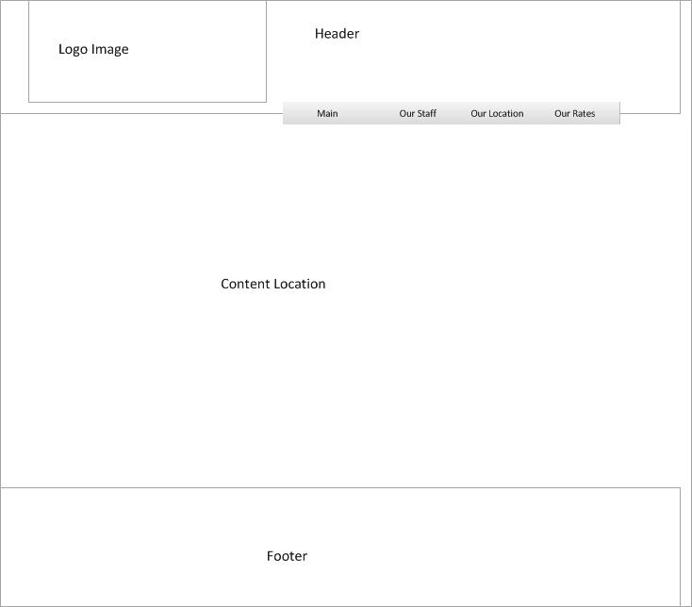

Sitemap
Straight Lines - Webpage connector
Curved red line – Indicator that the style.css file is connected to that page

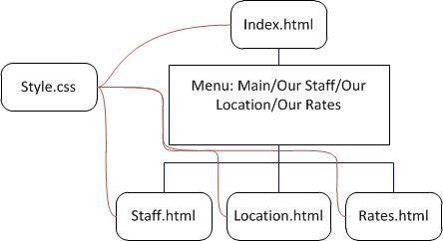

Page Content
Index.html – Initial page displayed on going to the sites domain, clicking the site logo image, or clicking Main on the navigation bar. Displays the desired content of primary goals of the business, provides contact phone numbers and email link.
Staff.html – Accessible via the Our Staff option on the navigation bar, Displays a listing of all the requested staff, and provides contact phone numbers and email link.
Location.html – Accessible via the Our Location option on the navigation bar, Displays a descriptive of where the business and location and provides a basic map (image) of where the business is located.
Rates.html – Accessible via the Our Rates option on the navigation bar, Displays a table with the rates that have been given for the business.
Footer Sidenote: Currently the footer section has been left empty, however the footer tags and css tags have been left in place so that if footer information is desired it can easily be edited in at a later date and time.

Other Site Elements

Color: The Site logo is a cheerful image of a rainbow, of the colors displayed a blue appealed the most for a cooler and more calming effect, also Rainbows are viewed in the Sky, which is blue, so the concept of the rainbow is carried through to the website itself. The primary background is a lighter blue, while the header and footer background is a dark blue, and the content background was left as white.
The lighter background blue, prevents the webpage from being beaten down by the darker blue in the header and footer areas, while the dark blue color in the Header and Footer areas act as a attention grabber to help draw the readers interest to the actual site content. The white background in the content area is for ease of readability.
Links placed within the content (currently only email links), have an altered color of a lighter blue with a mouse-over to a more purple color, allowing the reader to easily detect links within the content.
Fonts and Text: As no desired font information was given a basic font group of Verdana, Arial, Helvetica, sans-serif, was used for the site, and Text size was set at easily readable level.

