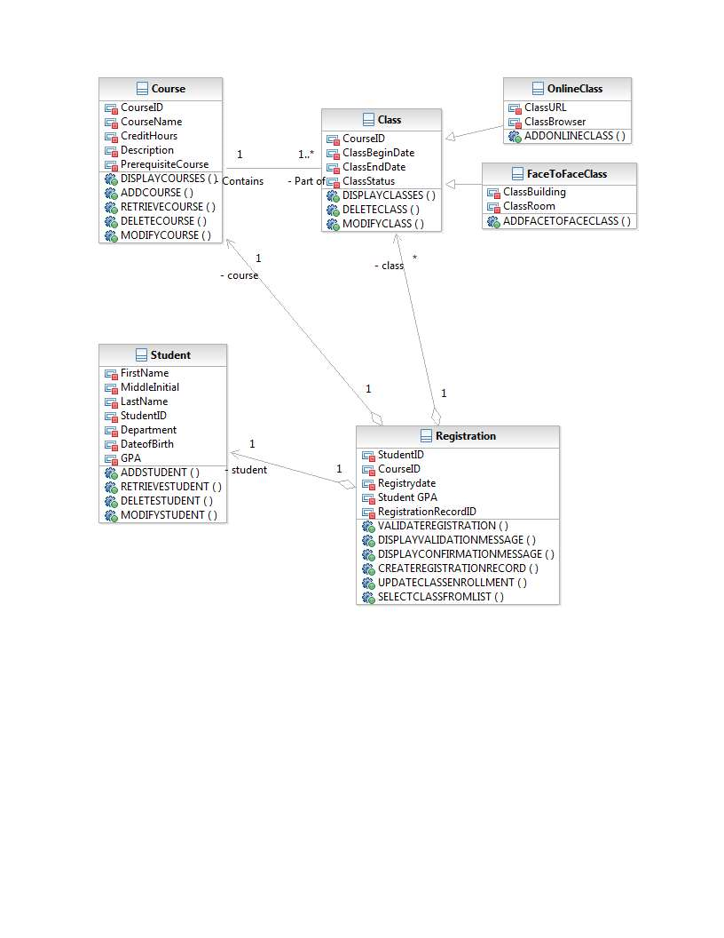

Front:
Class Name: Course | ID: ‎ 1 |  | Type: Concrete, Domain
Description: A Course that will contain classes to be taken by students. |  |  | Associated Use Cases: Maintain Course records
Responsibilities  Display Courses  Add Course  Retrieve Course  Delete Course  Modify Course |  | Collaborators

Back:
Attributes:
Course ID
Course Name
Credit Hours
Description
Prerequisite Course

Relationships:
Generalization (a-kind-of):

Aggregation (has-parts):

Other Associations:

Front:
Class Name: Class | ID: ‎ 2 |  | Type: Abstract, Domain
Description: Classes that are a part of a course to be taken by students. |  |  | Associated Use Cases: Maintain Class Records
Responsibilities  Display Classes  Delete Class  Modify Class  Add Class  Display Courses |  | Collaborators  Course

Back:
Attributes:
Course ID
Class Begin Date
Class End Date
Class Status

Relationships:
Generalization (a-kind-of):

Aggregation (has-parts):

Other Associations: Course

Front:
Class Name: OnlineClass | ID: ‎ 3 |  | Type: Concrete, Domain
Description: A class that is to be taken online |  |  | Associated Use Cases: Maintain Class records
Responsibilities  ADD Online Class  Delete Class  Modify Class |  | Collaborators  Class  Class

Back:
Attributes:
Class URL
Class Browser

Relationships:
Generalization (a-kind-of): Class

Aggregation (has-parts):

Other Associations:

Front:
Class Name: FaceToFacaeClass | ID: ‎ 4 |  | Type: Concrete, Domain
Description: A class that will be taken on campus |  |  | Associated Use Cases: Maintain Class Records
Responsibilities  Add Face to Face Class  Delete Class  Modify Class |  | Collaborators  Class  Class

Back:
Attributes:
Class Building
Class Room

Relationships:
Generalization (a-kind-of): Class

Aggregation (has-parts):

Other Associations:

Front:
Class Name: Student | ID: ‎ 5 |  | Type: Concrete, Domain
Description: Students that are registered for attending classes |  |  | Associated Use Cases: Maintain Student Records
Responsibilities  Add Student  Retrieve Student  Delete Student  Modify Student |  | Collaborators

Back:
Attributes:
First Name
Middle Initial
Last Name
Student ID
Department
Date of Birth
GPA

Relationships:
Generalization (a-kind-of):

Aggregation (has-parts):

Other Associations:

Front:
Class Name: Registration | ID: ‎ 6 |  | Type: Concrete, Domain
Description: Process for registering Students for classes |  |  | Associated Use Cases: Register a Student for Classes
Responsibilities  Validate Registration  Display Validation Message  Display Confirmation Message  Create Registration Record  Update Class Enrollment  Select Class from List  Display Courses  Display Classes  Retrieve Student |  | Course  Class  Student

Back:
Attributes:
Student ID
Course ID
Registry Date
Student GPA

Relationships:
Generalization (a-kind-of):

Aggregation (has-parts): Course, Class, Student

Other Associations:

Explanation
Diagram:

Attributes and Methods:

I pulled all of the variable names and function names directly from the SRS Activity Diagram and from the SRS Requirements Definition files.

Associations:

Class to Course: I used a regular association with one to many cardinality because while a you may only be working with one course at a time, that course can have many classes.

Class to OnlineClass/FaceToFaceClass: I used a parent to child relationship because a class is either online or face-to-face.

Registration to Student/Course/Class: I used aggregation associations from Student/Course/Class to Registration because Registration will be accessing part of those classes but not the entire class. In addition, as it would be pulling from more than one class, aggregation seemed to be more appropriate of a choice than just a standard association.

Registration to Student/Course cardinality: I specified these 1 to 1 because per registration record there can only be one student and one course for which they are registering.

Registration to Class cardinality: I specified this as one to many because a student can register for multiple classes at once so long as they pass the validation rules.

Attributes: I used normal spacing in the CRC cards so that the attributes are more readable; however, in the diagram I used CamelCase.

CRC Cards:

Name: The name of the class

ID: I assigned sequential ID numbers 1 – 6

Type: With the exception of the “class” CRC card, I assigned all of these to Concrete, Domain. Concrete because these objects should be able to be created, and domain because they are within the scope of the project domain. The “class” CRC card was assigned Abstract, Domain, because while it is still part of the project scope domain the “class” class should not be created on its own, as all classes must be either an online class or a face-to-face class.

Aside from this basic information and the Registration CRC card, the rest of the CRC cards should be self-explanatory as I double-checked them against the diagram multiple times.

The Registration CRC card requires further explanation because the attributes listed were not listed as part of the requirements but had to be individually determined.

I chose Student ID, Course ID, Registry Date, Student GPA, and Registration Record ID as the attributes for this class because you cannot register without these.
Student ID: Which student is registering?
Course ID: What class is being registered?
Registration Date: When did they Register?
Student GPA: What is the students current GPA for validation purposes?
Registration Record ID: What is the registration ID for this session so that this can be used as a reference if needed in the future?

I did not include anything else such as Term, because that is not included anywhere else in the required documents, as such it is assumed that the term information has already been specified during the display courses and display classes methods or already taken into account through other processes that are outside the scope of this assignment.

