CCSI460 Final Forensic Lab Report

Investigator’s Name: Matt Ferry

Date of Investigation: September 18, 2013

Lab Number and Title: Lab 3 Internet Research

Summary of Findings:

The Deep web is a huge part of the internet that will not be going anywhere anytime soon because of the nature of the Deep Web. The larger the Internet grows the more information that will be located on the deep web, especially when you consider that it is very rapidly becoming common practice for webpages to be dynamic instead of static.

In regards to image mapping tools like Google Earth, and Yahoo maps, I see these technologies doing nothing but improving, eventually to the point where satellite images are no longer years out of date, but potentially only weeks, days or even hours out of date.

Lastly, it does not take much information to turn minimal information into detailed information if someone knows what to look for and where. A Simple search for DeVry University, led to the address , and pictures of the actual building and location, and the corporate website which contained names and photos senior level members that could then lead to even more searches and potentially even more information that a criminal could use.

Details of Investigation:

9/18/13
11:04 AM – Beginning research into “Deep Web”

- What is meant by the "deep web"?

The deep web is a huge portion of the internet that primarily consists of webpages that are not indexed by search engines. These non-indexed web pages range from dynamic pages that are not capable of being indexed because they are not generated until a database query script generates the page, to that of pages that are not indexed because they are protected by username and password prompts. However, this is not where the deep web ends, because the deep web also consists of a large underground of webpages that exist on hidden anonymizing services or domains that are dynamically generated, such as webpages that are used in The Onion Router (TOR) network and end in .onion extensions (such as the silk road) .
- What does the future look like, concerning information from the "deep web" and the Internet?
Honestly, I see the future of the deep web, continuing for a very long time, with very little if anything can be done about it, especially in regards to the illegal pages and activities that occur within the deep web. This is primarily because of how the deep web is built on anonymity. By the time you find out enough information about a location or person on the deep web, I would expect that that location or person has already moved on in such a way that you have to start all over again in any type of investigation that may be in relation to the use of the “Deep Web” unless the criminal being investigated makes a novice mistake and wasn’t as “anonymous” as the thought they were.
- Compare and contrast capabilities of these three web applications: Google Earth, Yahoo Maps, and Windows Live Local (Virtual Earth).
All three of these utilities are mapping utilities that can be used to locate physical locations on the earth. Yahoo maps and Windows Live Local both appear to be more of a direction based applications, although Google earth can be used for the same thing. I say this because I see a distinction between Google Earth and Google maps, which I think, would be a more accurate comparison with Yahoo maps and Windows Live Local. My reasoning for this is that Google Earth requires an installation of some sort in order to be used, where the other two applications do not. If you want to use Google Earth through a web browser, you need the Google Earth plugin installed, and if you want the fully functional application, you have to install that on your desktop of choice.
Another major difference between these programs is that both Yahoo maps and Windows Live Local, while they allow you to zoom in close enough to see the physical location the images that you are presented are primarily from a Top down view, and they will only allow you to zoom in so far. Google Earth on the other hand allows you to zoom in all the way down to the street level and see a physical view of what the location looks like from the street, giving you information that is much more detailed about that location.
One particular thing of interest that I did note among these applications is that they use multiple databases of images. Take Windows Live Local for example. If you are viewing a location that has been around for a very long time it might not be as evident, but if you are viewing a location that has been recently constructed within the past few years, the images you may receive may be completely different based on what view you are currently in. A great example of this issue is my house that was constructed about 4 years ago. In the Birds eye view; you can see my house plus two others on the same side of the street. Yet if you switch to the aerial view, my house as well as other houses disappear because the image is an earlier image.
Out of these three applications, I would have to say that Google Earth is the most powerful if you consider it as a stand-alone application. However, in regards to Google Earths functionality as a web plugin, while you can still manually zoom in to any location that you want, from what I can tell the plugin does not have an easy search feature like the separate application, and therefore is not as useful as yahoo maps and Windows Live Local in that regard (Again we are talking about Google Earth, not Google Maps).
- Are there other applications, either free or commercial, that have similar capabilities?
Both Mapquest and Rand McNally provide similar mapping and direction functionalities through their webpages, of which neither of them require a fee to use.

9/22/13
12:21 PM – Answering Step2 of this week’s ILab
Information of Interest:
Administrative Offices
Highland Landmark V
3005 Highland Parkway
Downers Grove, IL 60515-5683
1-866-338-7934
1-866-DEVRY-34
Administrative Office Hours
Monday through Friday 9 a.m. to 5 p.m. CST.
This information is of interest because it provides the exact physical location of the DeVry Headquarters / Administration Building, provides several contact numbers as well as operating hours. While there is nothing unusual about this type of information, this is still information that could be used in social engineering.
Another interesting website in regards to DeVry is its corporate website
http://www.devryinc.com/ - This site is interesting because you can find out names and other specific information in regards to DeVry’s board of directors and other personal. Again there nothing unusual about this type of information but in mischievous hands information is power and the more information a person can gather the better their chances of success.

Top View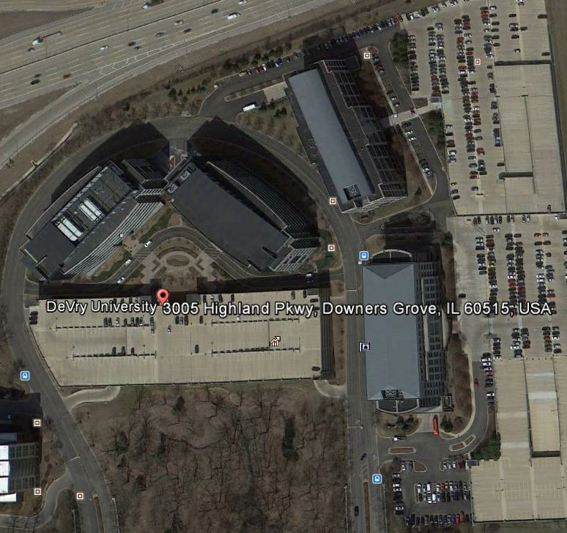

Street View

