CCSI460 Final Forensic Lab Report

Investigator’s Name: Matt Ferry

Date of Investigation: September 11, 2013

Homework Assignment: Week 2 – Verifying MD5 Sums

Summary of Findings:

The MD5 values are an exact match. The image.dd file is the same file that generated the md5 value that is located in the image.dd.md5 file.

Details of Investigation:

Homework assignment for Week 2 of Digital Forensics II: Download a zip file containing an Image.dd file and an image.dd.md5 file and verify that the hash value of the image.dd file matches the md5 value that is contained within the image.dd.md5 file.

9/11/13
10:40AM — downloaded and Extracted the zip file required for the week 2 homework assignment.
10:48AM --- Downloaded Md5sum and extracted the zip file.

10:49AM --- Opened the file image.dd.md5 in editpad lite
10:50AM --- Used MD5Sum to generate a hash value of image.dd
10:53AM --- Hash Values appear to match
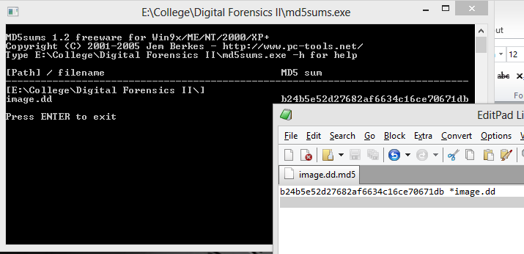

10:54AM --- Using Command Prompt Select All / Copy and Paste to copy the text information out of the command prompt for a closer examination.

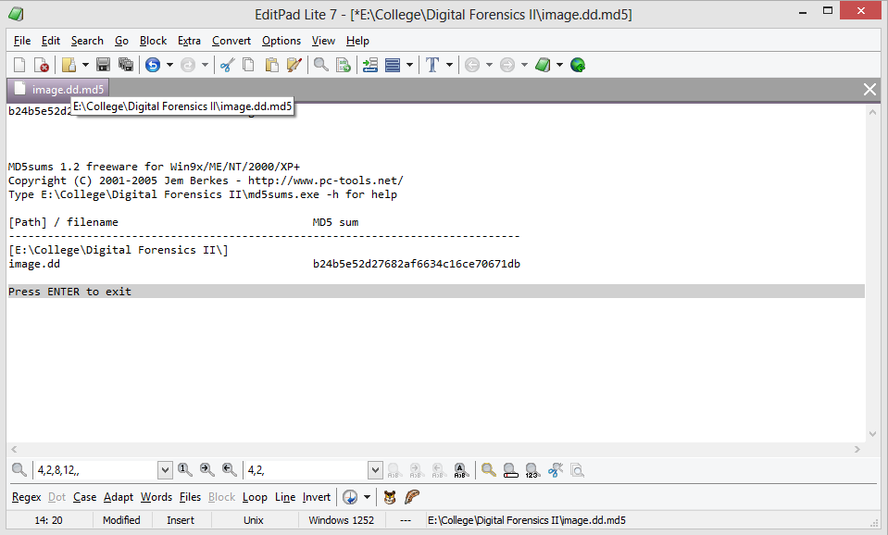

11:02AM – Selected excess text for removal
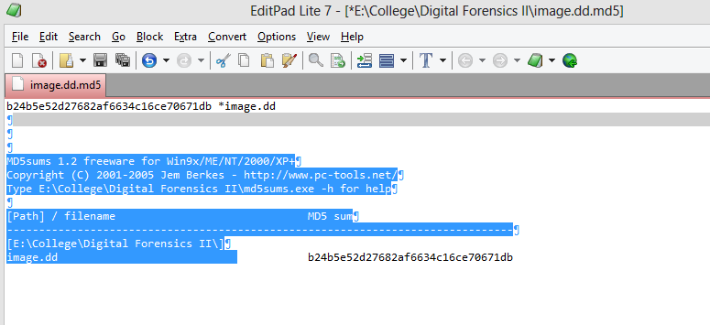

11:03AM --- Confirmed Md5 Hash values match
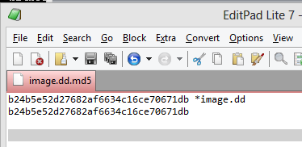

9/15/13
1:23PM – Reviewed the homework assignment before submission.

